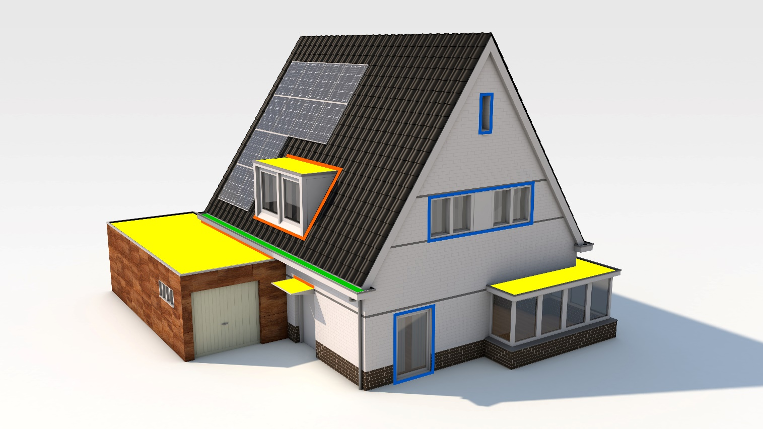

adhesive & sealant

GENERAL
Pandser Adhesive & Sealant is a 1-component moisture-curing hybrid Polymer adhesive sealant and has been specifically developed for bonding and sealing Pandser EPDM, roof trim connections, roof-wall connections and many details. The adhesive sealant cures by humidity to form a durable elastic joint. Pandser Adhesive & Sealant has neutral curing, almost odourless, and good UV resistance. This adhesive sealant contains no isocyanates and no silicones and has good adhesion to slightly damp substrates.

Pandser Adhesive & Sealant is highly resistant to (salt) water*, and has good chemical resistance, such as to dilute mineral acids and bases, ketones, alcohols, esters, hydrocarbons and aliphatic solvents**. Its temperature resistance is -40˚C to +90˚C. Pandser Adhesive & Sealant is not suitable for use in swimming pools/aquaria, and for bonding or sealing PE, PP, PC, PMMA, PTFE, soft plastics, neoprene , butyl and bituminous substrates. For use on other products or substrates, please contact Berdal first.

Pandser Adhesive & Sealant has good sprayability and can be processed with almost any sealant gun. The high initial adhesion of Pandser Adhesive & Sealant reduces the need for initial support. Due to the standing ability of this adhesive sealant, it remains in place during rolling.

* For flat roofs, in accordance with the Buildings Decree, ensure sufficient slope to prevent continuous water load
** not resistant to aromatic solvents, concentrated acids and chlorinated hydrocarbons

availability
Pandser Adhesive & Sealant is available as standard in the colour black in cartridge packaging:
Product description | Article number | EAN Code
Pandser Adhesive & Sealant 290 ml | WKFEP400-1080 | 8713331027470

RELATED PRODUCTS
Product description | Dimensions | Article number | EAN Code
Pandser Primer | 1 litre | WKFEP400-1075 | 8713331027067
Pandser Silicone seam roller 90 mm | Roller 90 mm | WKFEP400-1003 | 8713331040202
Pandser Silicone seam roller 45 mm | Roller 45 mm | WKFEP400-1002 | 8713331040196

applications
- Bonding and sealing of (non-adhesive) EPDM strips
- Bonding and sealing of aluminium roof trims and corner lines at roof edges
- Bonding of rainwater drains, cuffs and other accessories
- Bonding and sealing of seam overlays of Pandser EPDM sheeting

application
In unopened original packaging, Pandser Adhesive & Sealant has a minimum shelf life of 18 months from production date, as stated on the cartridge packaging. Store product between +10°C and +25°C in a dry place.
Application temperature: +5°C to +35°C. Substrates must be clean, grease- and dust-free. Adhesive sealant bonds perfectly without primer on Pandser EPDM and on most porous and non-porous substrates. Concrete or stony substrates should be pre-treated with Pandser Primer. Always test substrates in advance for adhesion and contact Berdal in case of doubt. Fresh material and tools can be cleaned using a suitable cleaner or white spirit. Cured material can only be removed mechanically. Cut the nozzle of the Pandser Adhesive & Sealant at the 3rd stripe (counting from the end of the nozzle) at an angle (approx. 45˚), so that a gross layer thickness of approx. 5 mm is achieved and ultimately a minimum layer thickness for bonding of over 1 mm is guaranteed. Apply Pandser Adhesive & Sealant on one side and bring the parts to be bonded together within the open time of 20 minutes without air inclusions and press on for approx. one minute and roll on top with the Pandser Pressure Roller. Total drying time is approx. 3 mm per 24 hours, depending on conditions and bonded materials. Consumption of one cartridge of Pandser Adhesive & Sealant is approx. 6.5 metres.
For detailed requirements per application, please refer to our detailed application instructions for Pandser on our website.

SAFETY DATA SHEET
For current and detailed information regarding chemical composition, safety aspects, handling, transport, storage and personal protection, etc., please refer to the Safety Data Sheet (SDS) of this product. Your supplier is in possession of the most recent document. You can also request it from Berdal.

